Audience feedback - age under 12

Yes No Don’t know/not sure
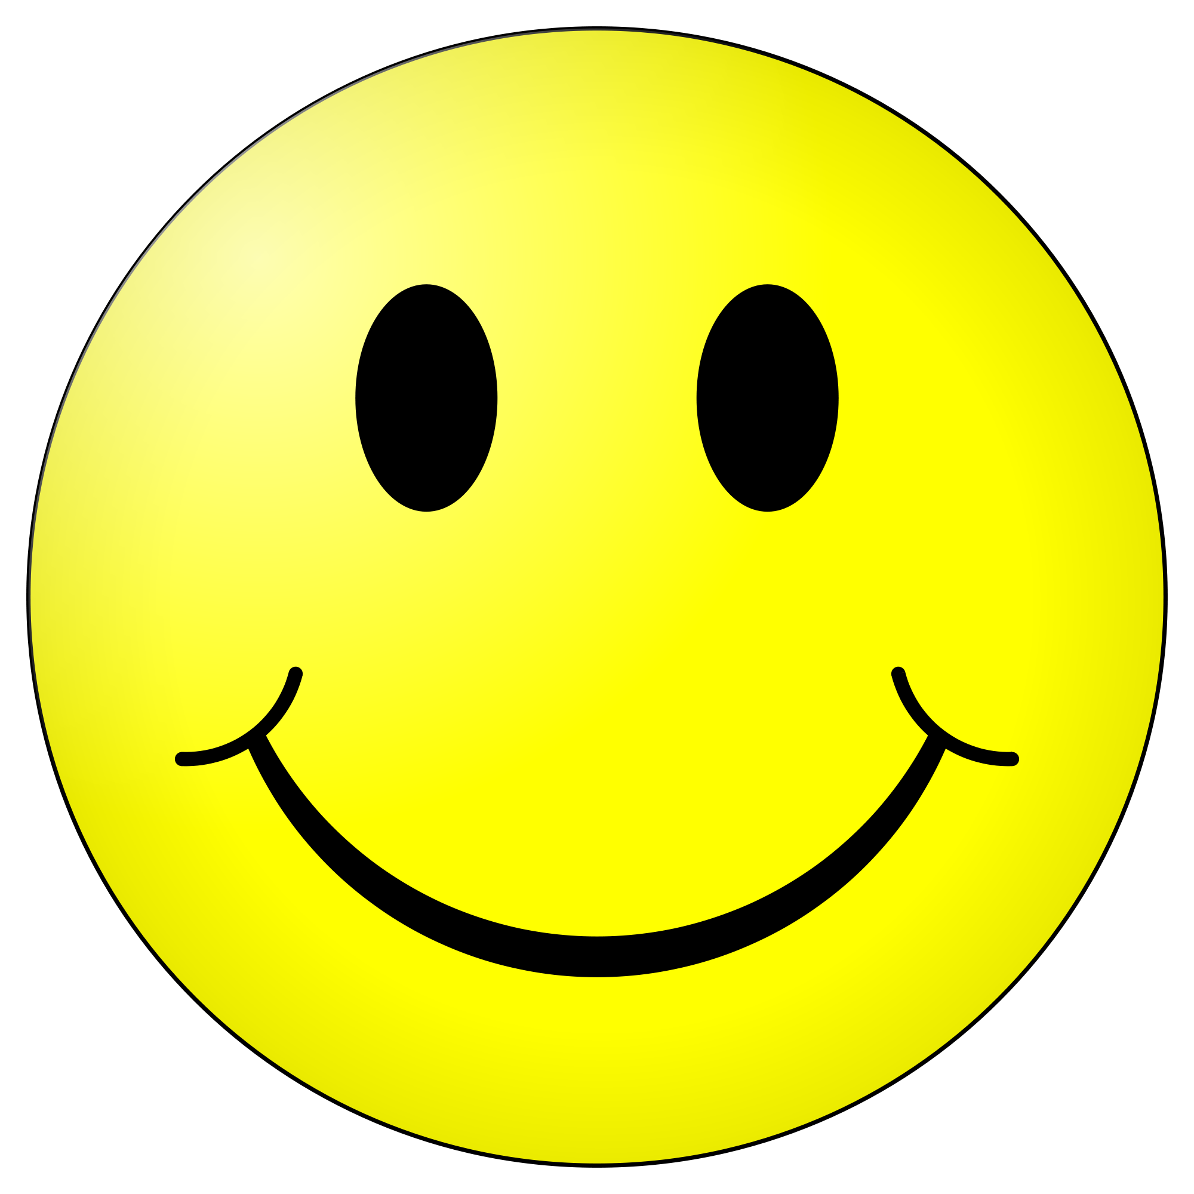
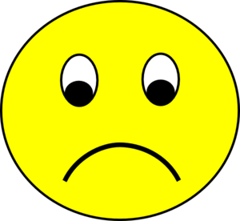
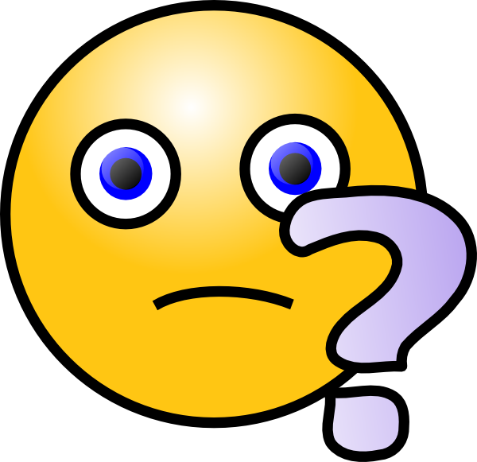

- Did you enjoy today’s event?
- Did you learn something new today?
- What did you learn today?

More Less No
Interested Interested Change

- How do you feel about science after today?

- What amazed you most at today’s event?

