300,000 different pathology tests are performed every working day across the UK. Write about an example from your time as a foundation doctor where one of these pathology tests had a significant impact/outcome for either you or your patient

Word count: 993
I was a foundation doctor in paediatric emergency department (PED) in the post-covid era of 2021-2022, which both challenged and developed me as a clinician. Late-presenting emergencies with non-specific symptoms such as sepsis, diabetic ketoacidosis¹ and PIMS-TS² were increasing, attributed largely to parental hesitancy of attending hospital due to potential COVID19 infection and disrupted access to community healthcare³. In addition to this, communication and history taking was challenging in paediatrics, related to the juvenile age of the patients or, on occasion, reluctance to disclose information in presence of caregivers. The combination of these factors created significant diagnostic uncertainty for me as an inexperienced clinician. This ultimately resulted in me appreciating the critical role of pathology tests in distinguishing between overlapping diagnoses and ultimately changing outcomes for vulnerable patients. This essay will focus on the case of an acutely unwell teenager and the pathology test that significantly impacted her ongoing care and life after diagnosis.
A 16-year-old female presented acutely unwell with abdominal pain, vomiting, and dysuria. Her only medical history was recent COVID19 infection. She denied being sexually active and completed her last menstrual period 2 days prior. On examination, she was shocked, pyrexic and peritonitic. Urinalysis was positive for protein and blood, negative for leucocytes and nitrites. Urinary pregnancy test was negative, and CT abdomen was unremarkable. Bloodwork showed a profound neutrophilia, leucopaenia, and raised inflammatory markers including proBNP, DDimer and ferritin. She was initially treated empirically with ceftriaxone as per paediatric sepsis protocol but commenced treatment for PIMS-TS.
After clinical improvement, I saw her without her parent present, and she disclosed that she had engaged in unprotected sex four months prior. She explained that she was frightened to disclose this information in front of her caregiver and because she was so acutely unwell in PED, both the patient and staff did not want them leaving her side. Considering this information, pelvic inflammatory disease (PID) became an important differential diagnosis. Vaginal swabs were taken from this patient for a full STI screen, which returned positive for Neisseria Gonorrhoea (NG) and Chlamydia Trachomatis (CT).
Nucleic acid amplification tests (NAATs) are considered the gold standard for STI testing in the UK and work by amplifying small amounts of genetic material to detect sequences of pathogens, such as CT and NG. It takes several forms, most common of which is polymerase chain reaction⁴, a three-step process at three respective temperatures, repeated 30-45 times to amplify genetic material to sufficient levels for detection (figure 1⁵). It is favoured for its high sensitivity (90-98%) in comparison to traditional bacteriology culture methods (35-80%)⁶ and 98-99% specificity⁷. In this case, the positive swab led to redirection of treatment from a post-covid inflammatory syndrome to targeted antimicrobial therapies for CT and NG.
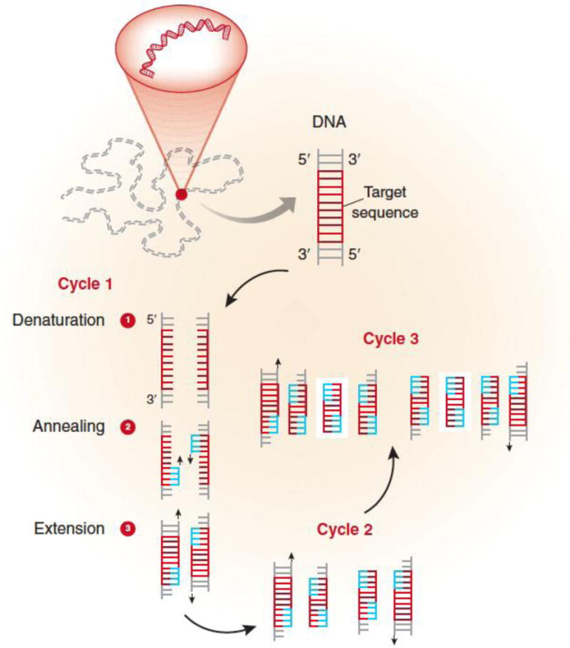
Figure 1: The process of PCR⁵.
Despite the high sensitivity and specificity of STI testing, the United Kingdom has the highest gonorrhoea incidence in Europe^{8,9}. Throughout the COVID19 pandemic, sexual and reproductive health (SRH) services were reduced significantly due to redeployment of staff and sickness, which acted as barriers to SRH services for young people who live with caregivers and felt unable to speak on the telephone¹⁰. Whilst there was a decrease in STI transmission in lockdown, there was a post-lockdown rebound, notably gonorrhoea in 15–24-year-olds with a 141% increase¹¹. This reflects the demographics of the patient, who, despite a non-judgemental approach to her care, remained nervous and apprehensive to reveal the diagnosis to her caregiver. We discussed this and explained to her that we could respect her confidentiality and not tell her mum anything directly related to her treatment. I empathised significantly with this young person, and it made me reflect on my own practice, highlighting the importance of confidentiality in adolescent histories. I became more assertive in asking the caregiver to leave so the patient felt that histories were honest and accurate. Explaining my rationale for asking personal questions ensured that the young person understood that I was asking to help identify possible causes for their symptoms.
Subsequently, the patient was treated for all infections as an inpatient and prescribed antibiotics to take home, making a full recovery. However, without this pathology test, her outcome could’ve been very different. Whilst she had one dose of ceftriaxone in PED, had she not received a full STI screen, it is likely that her treatment for PIMS-TS would’ve continued, undertreating CT. This would’ve left her with a risk of complications including PID and chronic pelvic pain, potentially leading to infertility and increased ectopic pregnancy risk¹². It also mitigated the need for a long admission, plus unnecessary and potentially detrimental treatments including high dose steroids, aspirin and plasma exchange.
This admission also gave the opportunity for the patient to be seen by the sexual health team, who could then educate her on the importance of barrier contraception and STI testing before and after each new sexual partner, equipping her with the knowledge to prevent reinfection and healthier SRH practises going forward. In addition, she learned where to access STI screening and the relatively non-invasive nature of the test, empowering her to take onus of her own health and removed the anxiety of the unknown in a supportive, non-judgemental environment. She reflected whilst in hospital and understood the ongoing importance of transparency in interactions with healthcare staff.
In addition, this allowed contact tracing for all sexual contacts of the patient. This minimised ongoing spread of infection and partners to be treated as early as possible, benefitting both the community and individuals, whilst providing an opportunity for SRH education to a wider audience.
In conclusion, this case demonstrates the pivotal role of NAAT in redirecting both diagnosis and treatment from PIMS-TS to PID sepsis. This enabled targeted antimicrobial treatment and follow up to mitigate chronic health risks, as well as partner tracing and wider SRH education. This not only had a profound impact on the patient but also highlighted the importance of confidential, non-judgemental clinical history-taking to me as a clinician.

Bibliography
1) Lynn, R.M., Avis, J.L., Lenton, S., Amin-Chowdhury, Z. and Ladhani, S.N. (2020). Delayed access to care and late presentations in children during the COVID-19 pandemic: a snapshot survey of 4075 paediatricians in the UK and Ireland. Archives of Disease in Childhood, 106(2), pp.e8–e8. doi:https://doi.org/10.1136/archdischild-2020-319848. [Accessed April 7th 2026].
2) Foster, A.A., Walls, T.A., Alade, K.H., Brown, K., Gausche‐Hill, M., Lin, S.D., Rose, E.A., Ruttan, T., Shahid, S., Sorrentino, A., Stoner, M.J., Waseem, M. and Mohsen Saidinejad (2023). Review of pediatric emergency care and the COVID‐19 pandemic. Journal of the American College of Emergency Physicians Open, 4(6). doi:https://doi.org/10.1002/emp2.13073. [Accessed April 6th 2026]
3) Conlon, C., McDonnell, T., Barrett, M., Cummins, F., Deasy, C., Hensey, C., McAuliffe, E. and Nicholson, E. (2021). The impact of the COVID-19 pandemic on child health and the provision of Care in Paediatric Emergency Departments: a qualitative study of frontline emergency care staff. BMC Health Services Research, 21(1). doi:https://doi.org/10.1186/s12913-021-06284-9. [Accessed April 7th 2026].
4) Center of Disease Control (2020). Labs. [online] Centers for Disease Control and Prevention. Available at: https://archive.cdc.gov/www_cdc_gov/coronavirus/2019-ncov/lab/naats.html. [Accessed April 17th 2026].
5) Garibyan, L. and Avashia, N. (2013) 'Polymerase chain reaction,' Journal of Investigative Dermatology, 133(3), pp. 1–4. https://doi.org/10.1038/jid.2013.1. [Accessed April 16th 2026].
6) Shao, L., Guo, Y., Jiang, Y., Liu, Y., Wang, M., You, C. and Liu, Q. (2016). Sensitivity of the Standard Chlamydia trachomatis Culture Method Is Improved After One Additional In Vitro Passage. Journal of Clinical Laboratory Analysis, 30(5), pp.697–701. doi:https://doi.org/10.1002/jcla.21924. [Accessed April 7th 2026].
7) Ángel, M., Héctor Toledo Porteros, De, A., Medel, J.V. and Borrero, I.G. (2024). Advantages of Syndromic Diagnostics: Detection of the Pathogens Causing Urethritis/Cervicitis with the STI CNM Real-Time PCR Kit from Vitro S.A. Polish Journal of Microbiology, [online] 73(4), pp.529–534. doi:https://doi.org/10.33073/pjm-2024-045.
8) Public Health England (2026). Fingertips | Department of Health and Social Care. [online] Phe.org.uk. Available at: https://fingertips.phe.org.uk/search/gonorrhoea [Accessed 8 Apr. 2026].
9) ECDC (2023). Surveillance Atlas of Infectious Diseases. [online] atlas.ecdc.europa.eu. Available at: https://atlas.ecdc.europa.eu/public/index.aspx. [Accessed April 8th 2026].
10) Sawyer, A., Aicken, C., Huber, J.W., Vera, J., Williams, D., Ali, M., Garcia-Camacho, G., Seuc, A.H., Sherriff, N., Bahamondes, L., Cecatti, J.G., Zotareli, V., Soeiro, R.E., Fernandes, K.G., Rogerio, M.B., Haddad, S.M., Bento, S.F., Padua, K.S., Munezero, A. and Charles, C.M. (2026). Contraceptive and sexual health services during the COVID-19 pandemic and recovery: a mixed-methods study in England. Reproductive Health, [online] 22(S3). doi:https://doi.org/10.1186/s12978-025-02184-x. [April 6th 2026]
11) Fountain, H., Migchelsen, S.J., Charles, H., Ram, T., Fifer, H., Mohammed, H. and Sinka, K. (2024). Rebound of Gonorrhea after Lifting of COVID-19 Preventive Measures, England - Volume 30, Number 2—February 2024 - Emerging Infectious Diseases journal - CDC. wwwnc.cdc.gov, [online] 30(2). doi:https://doi.org/10.3201/eid3002.231148. [Accessed April 6th 2026].
12) World Health Organization (2024). Chlamydia. [online] www.who.int. Available at: https://www.who.int/news-room/fact-sheets/detail/chlamydia. [Accessed April 16th 2026]

‌
‌
‌
‌

