Appendix C Draft request form for node dissections
Surname: | Consultant:
Forename: | Location:
Date of birth:
Sex:
Hospital no.: | NHS/CHI no.:

Relevant medical or dental history | Clinical diagnosis
Site of lesion: | Previous reports (lab no. if known)
Duration of symptoms: | Previous reports (lab no. if known)
Predisposing factors: | Other information (e.g. previous surgery, radiotherapy, chemotherapy, targeted or immunotherapy)
Date of operation:
Signature:

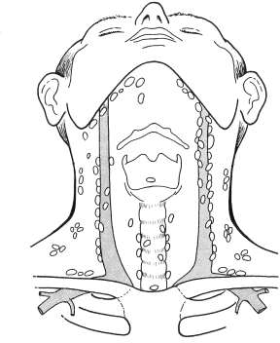
Please tick appropriate boxes:
Right
Left
 | Right neck dissection | Left  neck dissection
Levels submitted
I
II (total)
IIA
IIB
III
IV
V
VI
Other (specify)
Non-nodal structures
Sternomastoid
Submandibular gland
Internal jugular vein
Other (specify)

